From Weight-Space Diffusion to Latent-Space DeepSDF:
An Empirical Investigation of Image-Conditioned 3D Generation
at Small Data Scale
Aditya Jain
May 2026
An empirical study tracing the evolution of an image-to-3D system through twelve architectural iterations, from per-shape neural network weight prediction through compressed weight autoencoders to a working DeepSDF-style shared decoder with image-conditioned latent diffusion.

Abstract
We present a systematic empirical investigation of image-conditioned 3D shape generation under severe data constraints (≤976 training shapes, drawn from the LVIS subset of Objaverse). Across twelve experimental phases, we trace the failure modes and breakthrough points of three distinct architectural families: (1) per-shape neural-network weight prediction via image-conditioned diffusion in raw 54,785-dimensional weight space; (2) weight-space autoencoders that compress shape-specific MLP weights into low-dimensional latent codes for downstream diffusion; and (3) DeepSDF-style joint optimization of a single shared decoder with per-shape latent codes.
Our weight-space diffusion experiments reveal a structural failure mode at our data scale: the trained per-shape decoder weights occupy only a thin warm-started shell of the 54,785-dimensional weight space (mean pairwise cosine similarity 0.96), causing the diffusion model to collapse to a 4-shape attractor cluster regardless of input image. Subsequent ablations rule out the standardization, classifier-free guidance dropout, and prediction target as causes. Direct compression via a weight-space autoencoder achieves high numerical fidelity (cos(rec, true) = 0.997) but produces visually broken meshes for shapes with thin or topologically complex geometry, exposing a fundamental sensitivity of ReLU+positional-encoding networks to which dimensions absorb reconstruction error.
Pivoting to a DeepSDF-style architecture — a single shared decoder MLP (~1.95M parameters) with one learnable 64-dimensional latent code per shape, jointly optimized — produces clean reconstructions across all 976 training shapes (final SDF L1 = 0.00212; max per-shape error = 0.00593). An image-conditioned diffusion transformer (~10M parameters) trained to predict the 64-dimensional latent codes directly, conditioned on multi-view DINOv2 features and camera poses, achieves perfect recall on training shapes (cos(pred, true) = 1.000 for all tested shapes at K=1 view) and demonstrates genuine category-level out-of-distribution generalization at 976 training shapes — producing humanoid output for human input, head-shaped output for face input, and elongated output for tunnel input — behavior that was entirely absent in the 20-shape pilot, which exhibited pure nearest-neighbor retrieval.
We argue that the negative results from the weight-space approaches are themselves informative: they demonstrate that the warm-start prior — necessary for downstream weight-space interpolation in our prior work — paradoxically destroys the structural diversity that diffusion models require. The DeepSDF approach succeeds because it constrains per-shape variation to a 64-dimensional space by construction, rather than attempting to extract it from a 54,785-dimensional weight space dominated by shared anchor structure.

1. Introduction

1.1 Motivation
Image-to-3D generation has become a core problem in modern computer vision and graphics. Recent large-scale systems (Get3D, Shap-E, CRM, Zero-1-to-3) demonstrate impressive results when trained on hundreds of thousands to millions of shapes (Objaverse, Objaverse-XL). However, the practical reality of most research and engineering settings is data scarcity: a curated training set of a few hundred to a few thousand shapes, often domain-specific, is the realistic operating regime.
This work asks: what architectural choices matter when training image-to-3D systems with ~10³ shapes rather than ~10⁵? We are particularly interested in approaches that build on neural implicit representations — networks that map (point) → SDF or occupancy — because these representations are the foundation of most modern 3D generation pipelines.
The starting hypothesis was inherited from prior work in the same lab on hypernetworks and weight-space learning: if each shape is encoded as the parameters of a small MLP that defines its SDF, then 3D generation can be framed as predicting MLP parameters from images. This framing has theoretical appeal — it makes shape generation isomorphic to high-dimensional vector regression — and it composes naturally with diffusion models.
What follows is the empirical story of pursuing that hypothesis through eight architectural iterations, watching it fail in informative ways, and ultimately abandoning it in favor of a DeepSDF-style shared decoder. We document this process in detail because the failure modes are themselves the contribution: they reveal that warm-started per-shape MLPs, while powerful for unconditional weight-space interpolation, are catastrophically unsuitable for image-conditioned diffusion at small data scale.

1.2 Contributions
- A systematic empirical comparison of three image-to-3D architectural families (raw weight prediction, weight autoencoder + diffusion, DeepSDF latent + diffusion) at the 199-976 shape scale.
- A diagnostic methodology — ranking predicted outputs against the full set of training latents by cosine similarity — that cleanly distinguishes mode collapse from prediction noise from genuine generalization.
- Identification of the warm-start dominance problem: per-shape MLPs sharing a common initialization produce a weight distribution with mean pairwise cosine similarity ≥ 0.96, which is too concentrated for diffusion to extract per-shape signal at our data scale.
- A demonstration that ReLU+PE decoder weights are fragile to per-dimension reconstruction error in ways that are not captured by aggregate MSE or cosine similarity metrics — a failure of the autoencoder approach that is hidden by the metrics it optimizes.
- A working final pipeline (DeepSDF shared decoder + image-conditioned latent DiT) that produces clean recall at 976 training shapes and exhibits category-appropriate OOD generation, despite the small training set.

1.3 Document Structure
Section 2 reviews related work on neural implicit shape representations, weight-space learning, and image-conditioned 3D diffusion. Section 3 describes the dataset, watertight conversion pipeline, multiview rendering, and DINOv2 feature extraction common to all experiments. Section 4 presents the weight-space approaches (Phases 1, 6, 7, 8, 9), their failure modes, and the diagnostics that revealed the warm-start dominance problem. Section 5 covers the weight autoencoder experiment (Phase 10) and its visual-quality failure despite strong numerical metrics. Section 6 presents the DeepSDF pivot (Phase 11) and its scaling from 20 to 976 shapes. Section 7 covers the image-conditioned latent diffusion model (Phase 12), its recall and OOD behavior. Section 8 discusses limitations and proposes directions for further work. Section 9 concludes.

2. Related Work

2.1 Neural Implicit Shape Representations
DeepSDF (Park et al., 2019) introduced the framework of representing a class of shapes as a single conditional MLP f(z, p) → SDF, where z is a per-shape latent code and p is a 3D query point. Subsequent work explored alternative network architectures (SIREN with sinusoidal activations; Sitzmann et al., 2020) and hybrid representations that combine MLPs with explicit voxel grids or triplanes (NeuS, Instant-NGP, Local Implicit Grids).
A separate line of work investigated neural networks where each shape is encoded as the entire weight vector of a per-shape MLP (Functa, NeRF-W, hypernetwork-conditioned implicit fields). This 'weights as data' framing is appealing — it produces shape-specific networks with high reconstruction fidelity — but introduces the challenge of training generative models that operate over weight space directly.

2.2 Weight-Space Learning
HyperDiffusion (Erkoç et al., 2023) and subsequent works demonstrated that diffusion models can be trained to denoise neural network weight vectors. The key practical challenge is the dimensionality: a typical implicit shape MLP has 10K-100K parameters, much higher than the latent dimensions used in image diffusion (typically 4-128). Several mitigations have been proposed: chunking the weight vector into tokens, training a weight-space autoencoder, or modulating a shared base network with a small per-shape modulation vector.
Our prior work (jainaditya.in / Topic 03) established that per-layer hypernetworks can preserve genus-1 topology when reconstructing per-shape MLP weights, while monolithic hypernets destroy topology even at MSE ~10⁻⁷. We also demonstrated that warm-starting all shape MLPs from a single anchor is necessary for coherent weight-space interpolation, because it constrains all per-shape solutions to the same permutation neighborhood. Both findings inform the present work — and, as we shall see, the warm-start prior turns out to be a double-edged sword.

2.3 Image-Conditioned 3D Generation
Modern image-to-3D systems fall into several families. View-synthesis approaches (Zero-1-to-3, Stable-Zero123) produce novel-view renders and lift them to 3D via off-the-shelf reconstruction. Triplane-conditioned diffusion (Get3D, EG3D) generates a triplane representation that is rendered through a small NeRF/SDF decoder. Latent-set methods (Shap-E, CRM) generate a fixed-size latent that conditions a shared decoder, akin to DeepSDF but with image conditioning.
Our final architecture (Section 7) belongs to the third family, but the path to it traverses several ideas in the second and weight-space families. The data scale at which we operate (976 shapes from LVIS-Objaverse) is two to three orders of magnitude smaller than the training sets used by the systems above (10⁵-10⁷ shapes), and this scale gap is the dominant constraint on architectural choices.

3. Data and Common Pipeline

3.1 Dataset
The dataset is a 1000-shape curated subset of Objaverse (Deitke et al., 2023), filtered to shapes appearing in the LVIS category vocabulary (Gupta et al., 2019). Categories range from common objects (table, chair, lamp, bottle) to wildlife (dog, lion, beetle), tools (toothbrush, sharpie, pacifier), vehicles (cabin_car, surfboard), and unusual long-tail categories (banjo, escargot, signboard, Tabasco_sauce). After watertight conversion and SDF sampling, 976 shapes had clean output across both stages and form the working set for all experiments below.
Each shape's identity is recorded as both an integer obj_idx (0..975) and the original Objaverse hash UID, with a manifest.json providing the bidirectional mapping along with the LVIS category label.

3.2 Watertight Conversion and SDF Sampling
Raw Objaverse meshes are non-manifold and contain holes, internal geometry, and duplicate vertices. Following project-internal standards, all meshes are converted to watertight using the Houdini VDB pipeline: scatter ~1M points uniformly on the mesh surface, voxelize via VDB-from-particles (target voxel count ~1M), and convert the VDB back to polygons. This produces a closed manifold suitable for SDF sampling.
SDF samples are generated using mesh-to-sdf with 200,000 query points per shape, biased toward the surface (50% near-surface, 50% uniform in the unit cube). The samples are stored as obj_NNNN.npz with arrays points (200000, 3) and sdf (200000,). All shapes are normalized to a unit bounding sphere before sampling.

3.3 Multiview Renders
For image-conditioned phases, each watertight mesh is rendered from 64 viewpoints arranged on a Fibonacci sphere at distance 2.5 (computed via the golden-angle parameterization). Renders use pyrender with EGL: black background, gray-blue PBR material (baseColor [0.7, 0.7, 0.75], metallic 0.0, roughness 0.4), one headlight at the camera position and one rim light at (60° elevation, -30° azimuth). Resolution is 224×224 RGB. Camera poses (azimuth, elevation degrees) are stored in views.json.
Of the 976 working shapes, 199 had multiview renders from earlier project iterations; the remaining 777 were rendered for the present work. Total render time: ~13 hours on the experimental box (CPU-bound; pyrender uses EGL with minimal GPU). Four files were produced corrupt during a session disconnect and were re-rendered from the watertight mesh.

3.4 Image Features (DINOv2)
All multiview renders are passed through DINOv2-base/14 (Oquab et al., 2023) to produce a 768-dimensional CLS token per (shape, view). Renders are resized to 224×224 (the DINOv2 native resolution) and ImageNet-normalized. The full feature cache for 976 shapes × 64 views × 768 dims is 192 MB.

4. Weight-Space Diffusion: An Informative Failure
This section documents Phases 1 and 6-9, which together pursue the hypothesis that per-shape MLP weights can serve as the prediction target for image-conditioned diffusion. All experiments here ultimately fail in informative ways. The failures and their diagnostics are the focus.

4.1 Phase 1: Per-Shape ReLU+PE Decoders
We begin by training one decoder per shape, using a ReLU+PE architecture rather than SIREN. The choice of ReLU+PE over SIREN was deliberate: prior in-house perturbation benchmarks showed that ReLU+PE decoders tolerate much larger weight perturbations before reconstruction quality collapses (rel σ ≥ 0.34 vs SIREN's ≤ 0.17). For a downstream task where a diffusion model will produce noisy weight vectors, this robustness matters.

Architecture
Each per-shape decoder f_θ: ℝ³ → ℝ has the form:
point (3-dim)
→ positional encoding (6 frequency bands → 39-dim)
→ Linear(39, 128) + ReLU
→ Linear(128, 128) + ReLU
→ Linear(128, 128) + ReLU
→ Linear(128, 128) + ReLU
→ Linear(128, 1)
Total: 54,785 parameters.

Warm-Start Anchor
All 976 per-shape decoders are initialized from a single anchor decoder, trained on obj_0000 (a coffee table). The anchor itself is fit from random initialization using the standard L1-on-clamped-SDF objective. Per-shape decoders are then fit from this anchor for 200 epochs each at learning rate 10⁻⁴ with cosine decay. The motivation: warm-starting from a shared anchor keeps all per-shape decoders in the same permutation neighborhood, which prior work showed is necessary for coherent downstream weight-space interpolation.
Final per-shape losses: median 0.00185, 95th percentile 0.00409. Only 11/976 outliers above 0.01. Visual reconstruction quality is good across categories.

4.2 Phase 6/7: Image-Conditioned Weight Prediction
Phase 6 trains a diffusion transformer (DiT, ~132M parameters) to predict per-shape decoder weights from a single image. Phase 7 extends this to multiview conditioning with K∈[1,8] views and explicit camera-pose embeddings.

Architecture
The DiT chunks the 54,785-dim weight vector into 8 tokens of 6,849 dim each (after padding to 54,792). Each token is projected to d_model=768. The model has 8 layers with self-attention (within the 8 weight tokens) and cross-attention (to a variable number of view tokens). Each view token is the concatenation of (DINOv2 CLS, 64-dim sinusoidal pose embedding) projected to d_model. AdaLN modulation conditions on the diffusion timestep.
The diffusion process uses a cosine schedule with T=500 steps, x_0 prediction objective, and DDIM sampling at 50 inference steps. Classifier-free guidance is enabled with cfg_dropout=0.10 and pose_dropout=0.20.

Training
The DiT trains on 199 shapes (the subset that had multiview renders at the time of Phase 6). Variable K is sampled uniformly per batch. Per-dimension standardization is applied to the weight vectors using statistics computed over the 199 shapes (with std-floor 10⁻⁴ to avoid division by zero on near-constant dimensions).
Training loss EMA plateaus at 0.198 standardized MSE around step 15K. The loss does not decrease meaningfully beyond this point through 30K steps.

Diagnostic 1: Where is the Prediction Error?
To understand whether the 0.198 loss floor reflects prediction noise or something more pathological, we run diagnostic inference on four trained shapes (obj_0000 the table, obj_0050 a snowman, obj_0100 a turkey, obj_0119 a wolf) and rank the predicted weight vector against all 199 training latents by cosine similarity. The result is striking:
obj_0119 (wolf):
cos(pred, true)=0.9698
top-5 nearest training latents to PREDICTION:
#1: obj_0054 cos=0.9868
#2: obj_0172 cos=0.9868
#3: obj_0055 cos=0.9867
#4: obj_0000 cos=0.9854
#5: obj_0010 cos=0.9834
Across all four test shapes, the top-5 nearest training latents are the same four shapes — obj_0054, obj_0055, obj_0172, obj_0000 — regardless of input image. The prediction is closer to these attractors than to the true target shape (top-1 cos ≈ 0.987 vs true cos ≈ 0.97). The model is producing a tiny perturbation of the same 'mean shape' for every input.
This is mode collapse, but in an interesting form. The DiT has not collapsed to producing zero or random outputs; it has collapsed to producing the centroid of the training distribution, with image conditioning supplying a roughly 3% directional perturbation that is insufficient to move it toward the correct target.

Diagnostic 4: Is the Loss Uniform Across Timesteps?
A natural follow-up hypothesis is that the loss floor reflects a prediction-target mismatch — perhaps x_0 prediction is hard at high noise levels and ε-prediction would help. We measure the loss at 10 timesteps spanning [0, 450]:
timestep t | alpha_bar(t) | MSE(x_0) | MSE(ε_implied)
0 | 0.9999 | 0.18912 | 2164.16
50 | 0.9711 | 0.18286 | 6.13
100 | 0.8968 | 0.18700 | 1.63
150 | 0.7844 | 0.19018 | 0.69
200 | 0.6445 | 0.18563 | 0.34
250 | 0.4907 | 0.18672 | 0.18
300 | 0.3379 | 0.19423 | 0.10
350 | 0.2006 | 0.19052 | 0.05
400 | 0.0922 | 0.18849 | 0.02
450 | 0.0231 | 0.19252 | 0.005
The x_0 loss is essentially flat at ~0.19 across all timesteps. Most importantly, at t=0 (where the input is essentially the clean target plus a tiny amount of noise), the loss is still 0.189 — meaning the model cannot even reproduce a near-clean input. This rules out the prediction-target hypothesis. It also rules out 'just train longer' — the loss floor is structural, not optimization-bound.

4.3 Ablations: Standardization and Dropout (Phases 8 & 9)
Two natural hypotheses for the mode collapse remain. First, that per-dimension standardization is at fault: 124 of the 54,785 dimensions had std < 10⁻⁴ across the 199 training shapes and were clamped to 10⁻⁴ before standardization. This artificially amplifies near-constant dimensions to unit scale, which the model trains to predict consistently — and ends up doing so for all dimensions. Second, that classifier-free guidance dropout — 10% of training samples drop all view conditioning, forcing the model to learn an unconditional distribution — pushes the model to predict the dataset mean.
We test each in turn.

Phase 8: Raw Weights, No Standardization
We retrain the DiT with identical architecture and hyperparameters but on raw (unstandardized) weight vectors. Loss values become incomparable to Phase 7 (different scale), but the diagnostic structure is unchanged. After 5K steps, the same diagnostic shows the same pattern: top-1 to top-3 nearest training latents to the prediction are still obj_0054, obj_0055, obj_0172 across all test shapes. Mode collapse persists.

Phase 9: No Dropout
We retrain again with cfg_dropout=0.0 and pose_dropout=0.0, removing all unconditional training. Loss curve is essentially identical to Phase 8. Diagnostic at step 5K: same attractor cluster, same top-1 mode collapse to obj_0055. The CFG dropout was not the cause.

Diagnostic 5: Characterizing the Training Distribution
We measure the geometry of the 976 trained per-shape decoder weight vectors directly:
Statistic | Value
Mean L2 norm of weight vectors | 13.39
Std of L2 norm | 0.10 (0.7% of mean)
Mean pairwise cosine similarity | 0.9606
Min/max pairwise cos | 0.927 / 1.000
Mean distance from population mean | 2.64 (19.7% of L2 norm)
Cos to mean: obj_0054 | 0.9951
Cos to mean: obj_0055 | 0.9951
Cos to mean: obj_0172 | 0.9950
Variance captured by top 10 dims | 0.2%
Variance captured by top 1,000 dims | 11.2%
Variance captured by top 10,000 dims | 55.4%
Variance captured by top 25,000 dims | 84.7%
The diagnosis is now clear. The 976 trained decoder weight vectors are highly concentrated: pairwise cos = 0.96 means all shapes are essentially small perturbations of a shared mean. The three attractor shapes (0054, 0055, 0172) have cos-to-mean = 0.995 — they are literally the most central shapes in the dataset, the ones closest to the centroid. The DiT's predictions land at the centroid because that is the easy minimum, and per-shape variation is spread thinly across ~50,000 dimensions, each with std ≈ 0.0008.
This is the warm-start dominance problem. The shared anchor initialization ensures that per-shape decoders end up in the same permutation neighborhood — desirable for the original goal of weight-space interpolation — but it concentrates the entire training distribution in a thin shell of weight space. There is per-shape signal in this shell, but it is buried under the shared structure: the DiT learns the easy 'predict the anchor' minimum and never has the gradient signal to escape it.

5. Weight Autoencoder: Numbers vs Meshes
Given the warm-start dominance problem, a natural intervention is to compress weight vectors before passing them to the diffusion model. If we can find a low-dimensional latent that captures per-shape variation cleanly, a diffusion model trained on those latents would have a tractable target.

5.1 Architecture
We train an MLP autoencoder on residuals from the population mean. The encoder maps 54,785-dim residual → 1024 → 1024 → 1024 → latent_dim, the decoder mirrors this. We test latent_dim ∈ {128, 256}. The autoencoder trains on all 976 weight vectors for 2000 epochs at lr=3×10⁻⁴ with cosine decay. Loss is per-element MSE on the residuals.

5.2 Numerical Results: Strong
Both latent dimensions converge to similar metrics:
Metric | latent_dim=128 | latent_dim=256
Final MSE (raw weight space) | 2.28×10⁻⁵ | 2.24×10⁻⁵
cos(rec, true) mean | 0.9965 | 0.9966
cos(rec, true) min | 0.9921 | 0.9920
Pairwise cos in latent space | 0.0676 | 0.0791
The latent space pairwise cosine drops from 0.96 (raw weight space) to 0.07 (latent space). Different shapes are mapped to essentially orthogonal directions. By every metric an autoencoder optimizes, this is excellent compression.

5.3 Visual Results: Catastrophic
When we decode the trained latents back through the autoencoder and pass the resulting weights to the original ReLU+PE network for marching cubes, the meshes tell a different story:
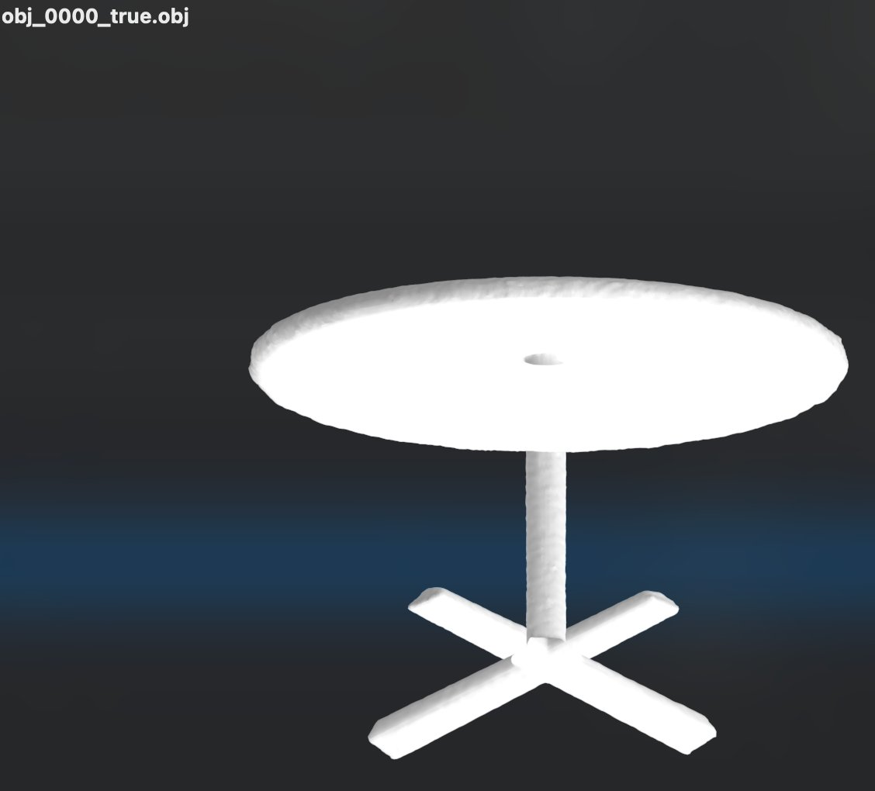
Original obj_0000 (table). Reconstruction through AE failed marching cubes entirely (SDF range [-1.07, -0.06] — no zero crossing).
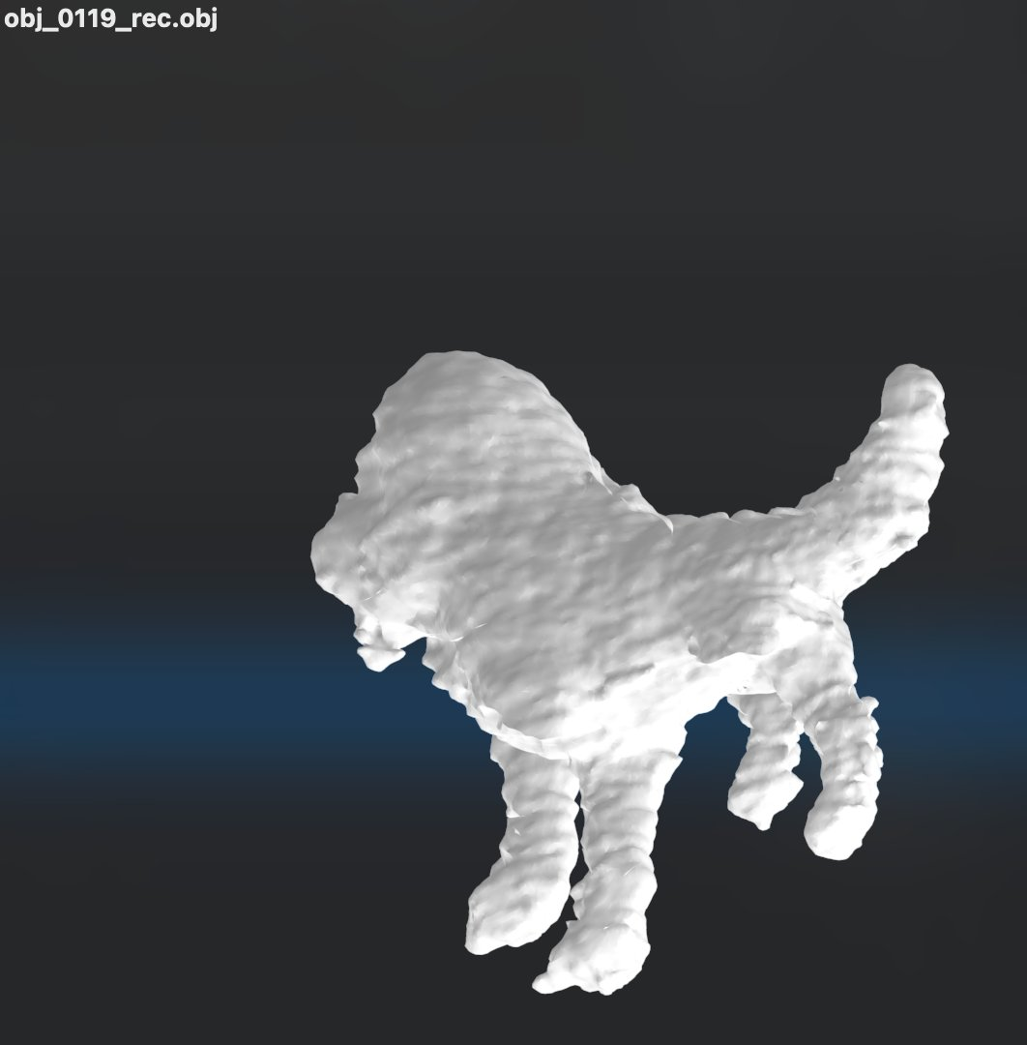  obj_0100 ground truth (turkey) | 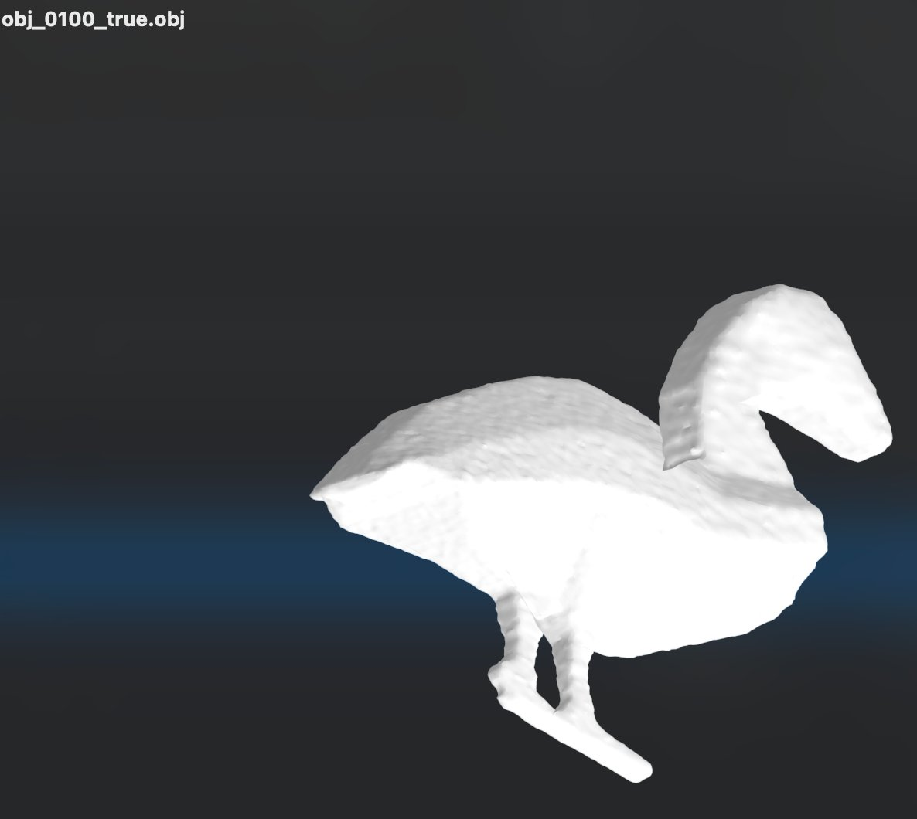  AE reconstruction
Figure 1: Phase 10 weight-AE reconstruction. Numerical fidelity (cos = 0.994) hides catastrophic structural failures. The bird's neck, head, and legs are gone — the topology is lost.
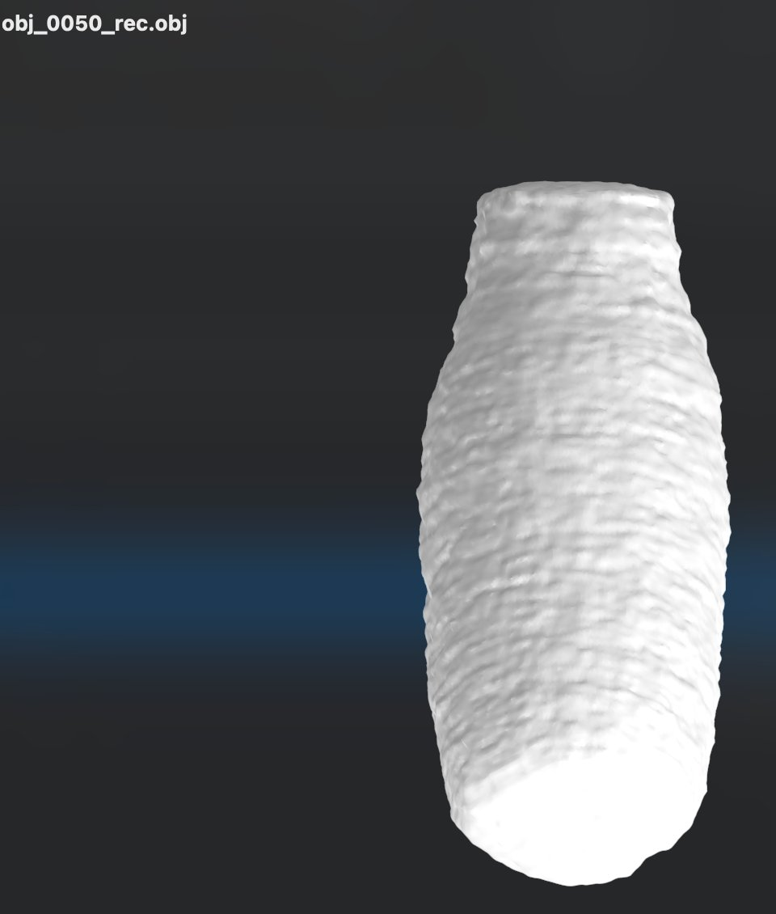
Phase 10: obj_0050 (vase) — one of the few shapes that reconstructs well. The vase has simple convex geometry; errors land on dimensions that don't affect the SDF zero-crossing.

5.4 Diagnosis
The 0.5% reconstruction error in latent_dim=128 is not uniformly distributed. It lands on different dimensions for different shapes, and ReLU+PE decoders are highly sensitive to which specific dimensions absorb that error. For obj_0050 (a vase), errors land on dimensions whose perturbation produces small surface displacements — the vase still looks like a vase. For obj_0000 (a table) and obj_0100 (a turkey), errors land on dimensions that control the bias of the final layer or the placement of the SDF zero crossing — the topology is destroyed.
Increasing latent_dim from 128 to 256 does not help. The visual failure persists. The issue is not compression ratio but the fragility of ReLU+PE decoders: weight perturbations that are small in MSE can be catastrophic in SDF space, and an autoencoder trained on weight MSE has no way to know which perturbations are catastrophic.
This finding parallels and reinforces our prior result on per-layer hypernetworks (Section 2.2): aggregate weight MSE is a poor proxy for shape reconstruction quality. The autoencoder approach inherits this weakness directly.

6. Phase 11: DeepSDF Shared Decoder

6.1 Architectural Pivot
The fundamental issue with the weight-space approaches is that they treat each shape's MLP weights as independent — each shape has its own ~55K-dim representation, and any compression must be learned post-hoc. The DeepSDF architecture inverts this: a single shared decoder is trained jointly with one learnable latent code per shape, so that per-shape variation lives in a low-dimensional latent space by construction.
Concretely:
Phase 6/7 (failed):
image -> DiT -> 54,785-dim weight vector
weight vector -> per-shape ReLU+PE network -> SDF
Phase 11 (works):
shape_id -> 64-dim latent z (learned)
f_shared(concat(z, PE(p))) -> SDF
where f_shared is a single MLP, ~1.95M params total
The 'compression' from 54,785 → 64 dimensions is not learned by an autoencoder; it is enforced by the training procedure. The shared decoder must use the 64-dim latent to differentiate shapes; otherwise it cannot fit them.

6.2 Architecture Details
The shared decoder has 8 hidden ReLU layers of width 512, with a DeepSDF-style skip connection that re-injects the input vector at the middle layer. Input is concat(latent_64, PE_3+6×6=39) = 103 dimensions. Output is a single SDF scalar.
Each shape's latent is a learnable parameter, initialized i.i.d. from N(0, 0.01²) and optimized jointly with the decoder weights. We use separate Adam learning rates: 5×10⁻⁴ for decoder, 10⁻³ for latents (latents typically need higher LR to escape their initialization). An L2 regularizer (weight 10⁻⁵) on the latent norms keeps them tight.
Training objective: clamped L1 loss on SDF predictions, ‖clamp(pred, ±0.1) − clamp(target, ±0.1)‖₁, plus the latent L2 regularizer. We sample 4 shapes per training step, 8,192 random points per shape per step.

6.3 Initial Pilot: 20 Shapes, 800 Epochs — Fails
We first attempt a pilot with 20 shapes, decoder hidden=256, 4 hidden layers, 800 epochs. The numbers look healthy:
Metric | Value
Final per-shape SDF L1 (mean) | 0.00613
Final per-shape SDF L1 (max) | 0.01069
Latent pairwise cos | -0.04 (essentially orthogonal)
Training time | ~1 minute
But the reconstructed meshes are blob-quality:
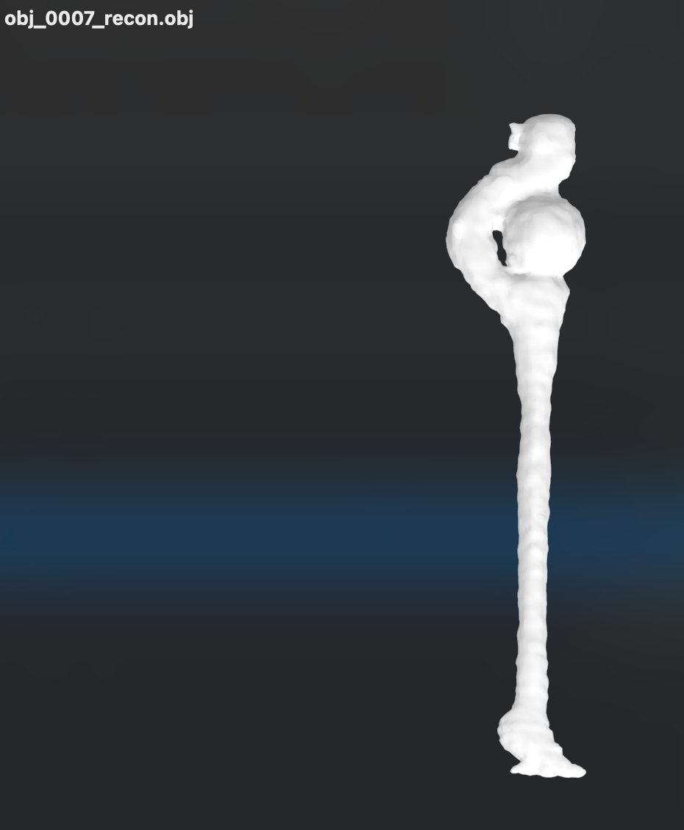  obj_0007: thin blob with bulb | 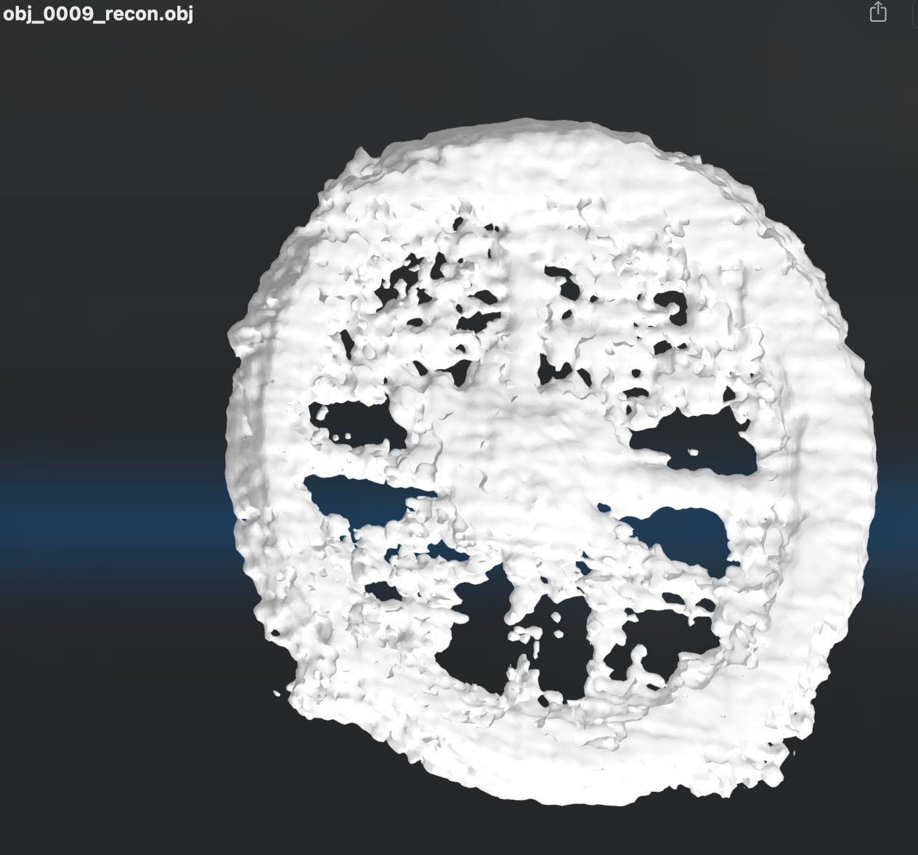  obj_0009: pitted sphere | 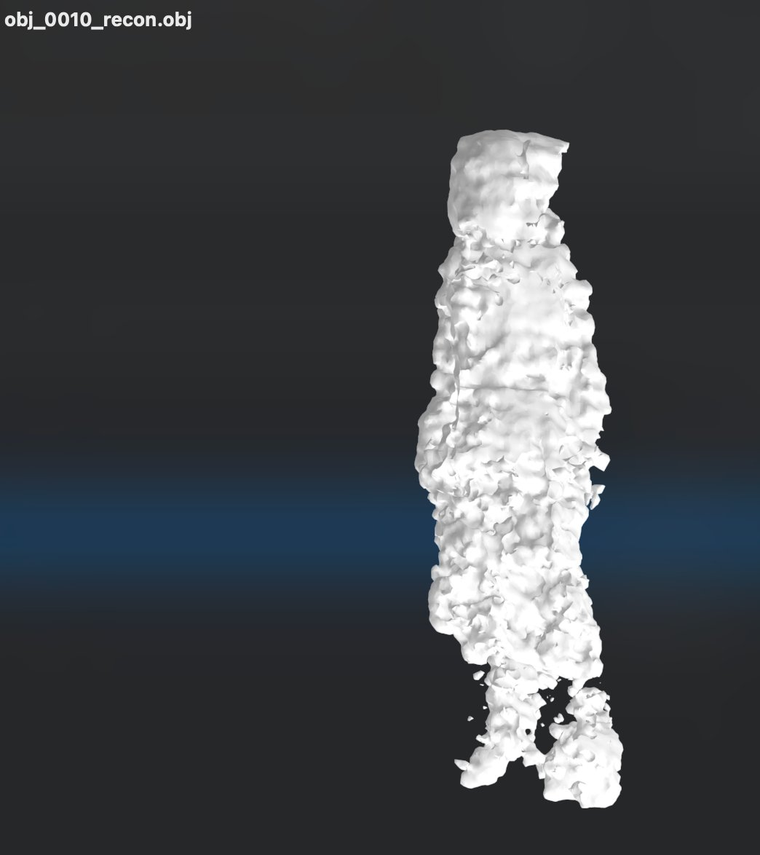  obj_0010: amorphous column
Figure 2: Initial Phase 11 pilot (20 shapes, decoder 256×4, 800 epochs). Loss values look reasonable but the meshes are visually broken. The decoder lacks capacity to represent 20 distinct shapes through a 64-dim latent.

6.4 Scaled Pilot: 20 Shapes, Bigger Decoder, 4000 Epochs — Works
Increasing decoder capacity to 512 hidden × 8 layers (~1.95M params) and training for 4000 epochs produces clean reconstructions:
Metric | 256×4, 800 ep | 512×8, 4000 ep
Final SDF L1 (mean) | 0.00613 | 0.00051
Final SDF L1 (max) | 0.01069 | 0.00090
Latent pairwise cos | -0.04 | -0.04
Training time | ~1 min | ~13 min
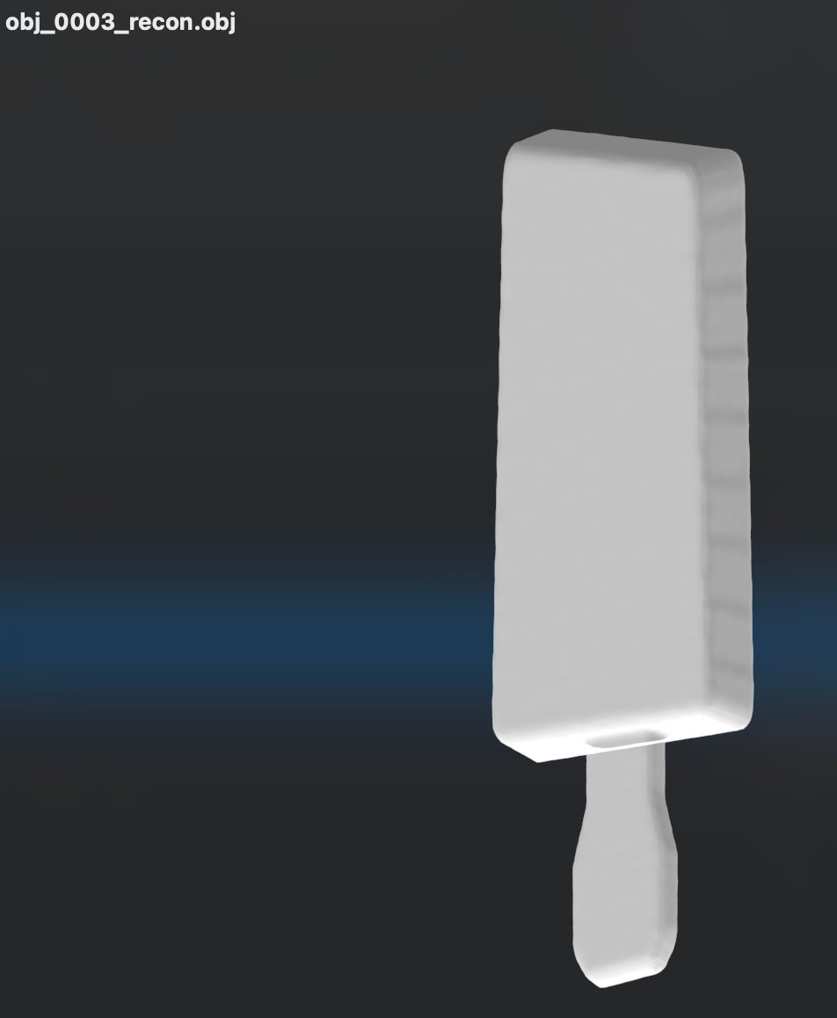  obj_0003: sword/blade | 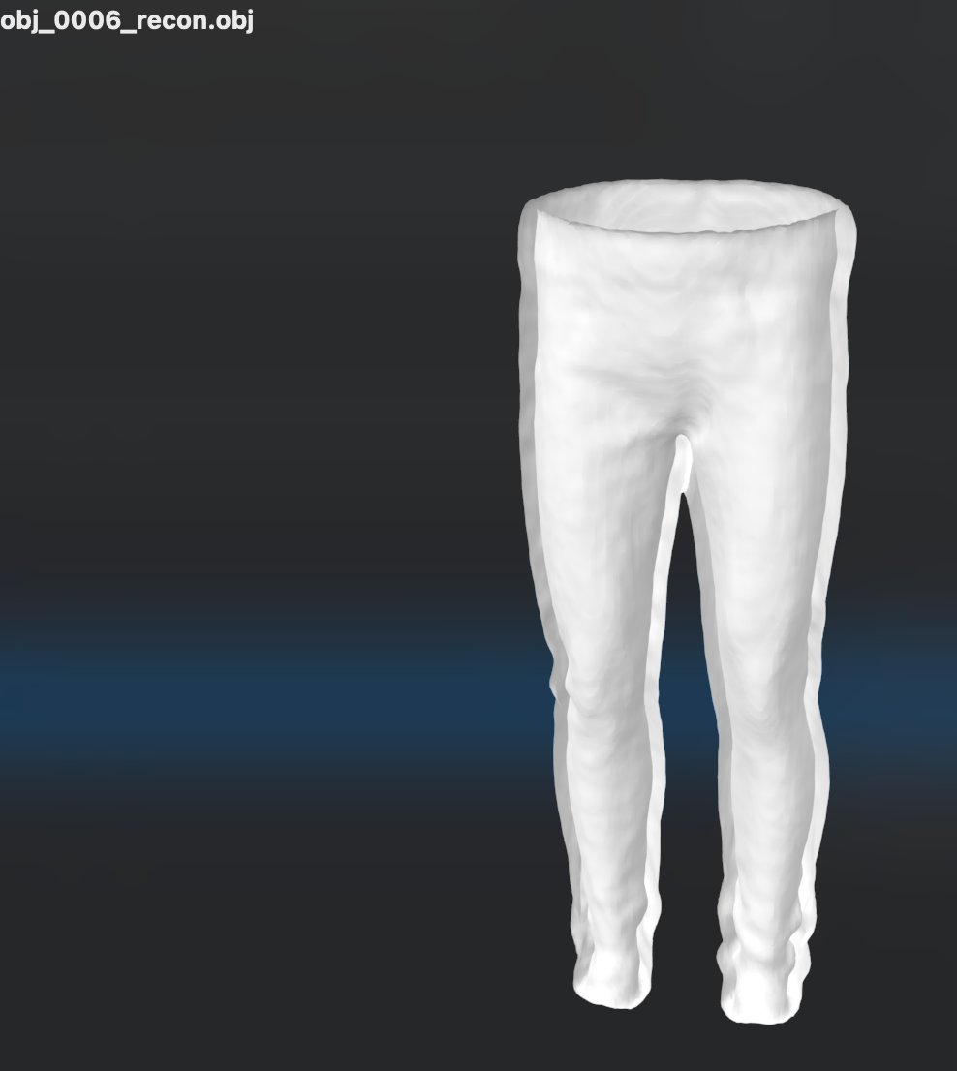  obj_0006: pants | 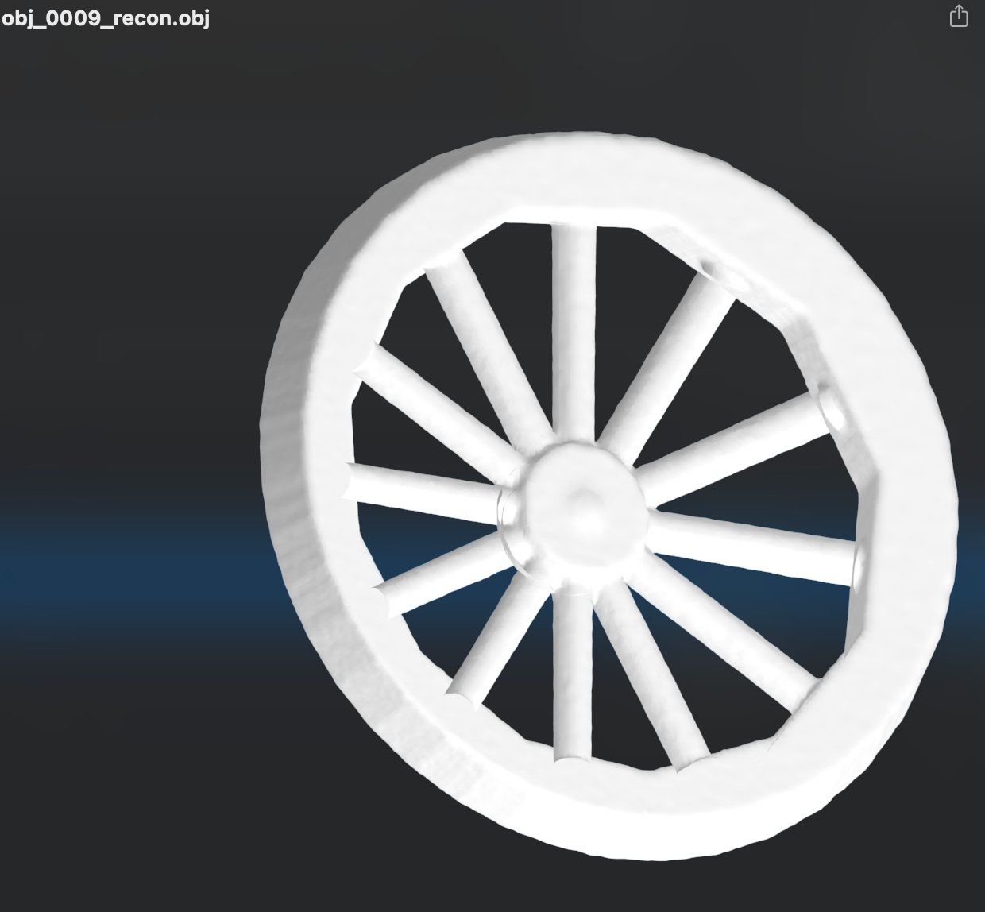  obj_0009: wagon wheel
Figure 3: Scaled Phase 11 pilot (20 shapes, decoder 512×8, 4000 epochs). All 20 shapes reconstruct cleanly. The wagon wheel — with 13 distinct spokes, hub, and outer rim — is preserved with razor-sharp thin geometry that catastrophically failed in every prior architecture.

6.5 Scaling to 976 Shapes
We retrain on all 976 shapes with the same architecture and 1500 epochs (down from 4000; the 20-shape run had effectively converged by epoch 1500). Periodic checkpointing every 200 epochs is added as a safety net.
Metric | 20 shapes (512×8, 4000 ep) | 976 shapes (512×8, 1500 ep)
Final SDF L1 (mean) | 0.00051 | 0.00212
Final SDF L1 (max) | 0.00090 | 0.00593
Latent pairwise cos | -0.04 | 0.12
Latent ||z|| (mean) | 0.71 | 2.90
Training time | 13 min | 140 min
The mean SDF L1 grows from 0.00051 to 0.00212 — about 4× — but every individual shape stays well below 0.006. None catastrophically fail. The pairwise cosine of latents grows from -0.04 to 0.12 (still mostly orthogonal — the 64-dim space has enough room for 976 distinguishable shapes).
The worst 10 shapes by final loss are spread across categories (obj_0727, obj_0196, obj_0898, obj_0608, obj_0076, obj_0395, obj_0449, obj_0328, obj_0018, obj_0905), with no obvious common failure mode. Visual inspection confirms they are still recognizable shapes; the decoder has not given up on them.

7. Phase 12: Image-Conditioned Latent Diffusion

7.1 The Prediction Problem, Revisited
With Phase 11's 64-dim latents in hand, the image-to-3D problem reduces to: given image features (and camera poses), predict a 64-dim latent that decodes to the correct shape. This is a small-dimensional supervised learning problem with multimodal output (multiple latents could correspond to similar images), making diffusion the natural choice.

7.2 Architecture
The DiT takes the 64-dim latent (treated as a single token of input dimension 64), projected to d_model=384. Four DiT layers (vs Phase 7's eight) with 6 attention heads. Each layer has self-attention (over the 1 latent token, effectively a noop), cross-attention to multi-view tokens, and a feedforward block. Each view token is the concatenation of (DINOv2 CLS-768, 64-dim sinusoidal pose embedding) projected to d_model. AdaLN modulation conditions on the diffusion timestep.
Total parameters: ~10M (vs Phase 7's 132M). The smaller model is appropriate because the prediction target is 800× smaller.
We standardize the trained Phase 11 latents to zero-mean unit-variance per dimension (computed across the training set). This is a common and stable preprocessing step for diffusion targets.
Training: 15K steps, batch=32, lr=3×10⁻⁴ with cosine decay, K∈[1,8] views uniformly sampled per batch. CFG and pose dropout are disabled (Phase 9 confirmed they were not the cause of mode collapse, and they are unnecessary at this scale). Cosine T=500 noise schedule, x_0 prediction.

7.3 The 20-Shape Pilot: Pure Memorization
We first run the full pipeline on the 20-shape pilot. Training loss EMA reaches 8×10⁻⁶ — essentially zero. Recall on training shapes is perfect:
obj_0009 (wagon wheel) at K=1 view:
cos(pred, true) = 1.0000
L2 error = 0.002
top-5 nearest training latents to PREDICTION:
#1: obj_0009 cos=1.0000 <-- TRUE
#2: obj_0012 cos=0.3387
#3: obj_0007 cos=0.3238
#4: obj_0006 cos=0.3219
#5: obj_0001 cos=0.3215
All five tested training shapes have cos = 1.0000 to their true latent, with a > 0.4 margin to the second-nearest training latent. The pipeline works end-to-end:
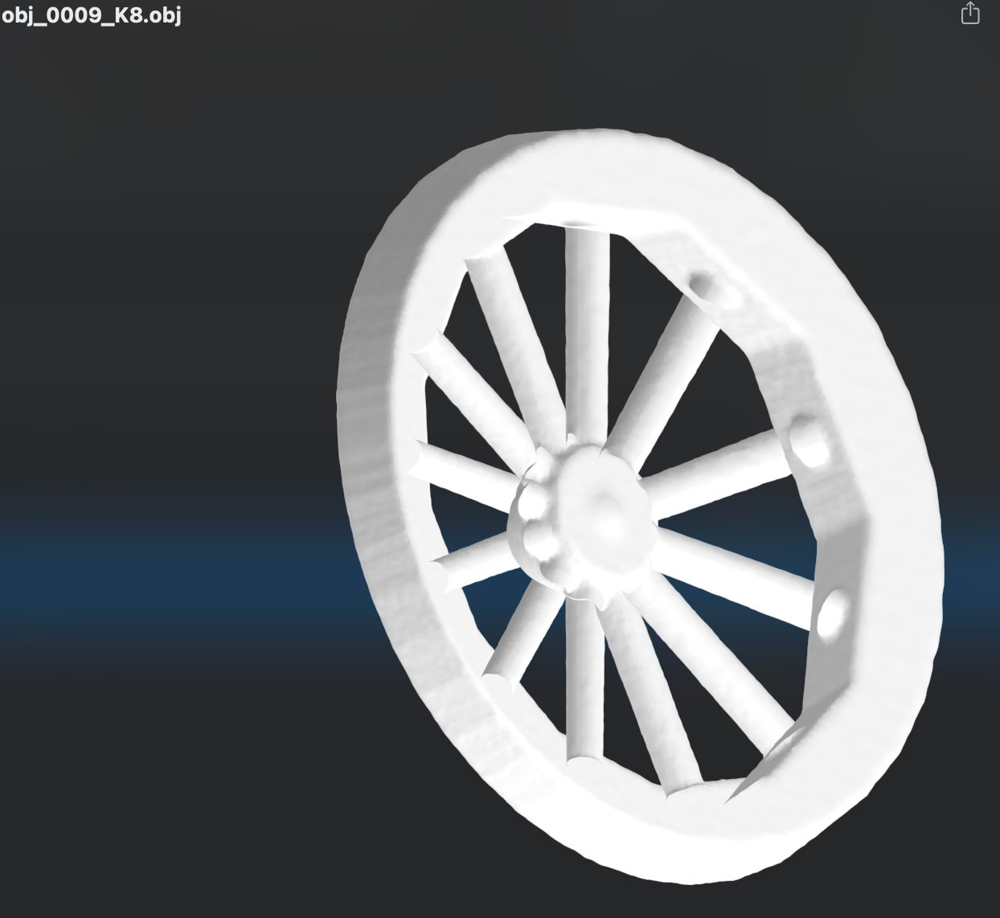
20-shape recall: feeding obj_0009's view-0 image through DINOv2 → DiT → decoder → marching cubes produces the correct wagon wheel mesh (compare to Figure 3, right).

OOD at 20 Shapes: Pure Retrieval
But OOD generalization fails almost completely. Feeding the model an image of an arbitrary held-out shape (a tunnel mesh, simple geometry: 3,939 verts) produces a prediction whose top-1 nearest training latent is obj_0000 (the table) with cos = 0.9661 — a margin of 0.36 above the second-nearest. The model has snapped to its closest training-set match:
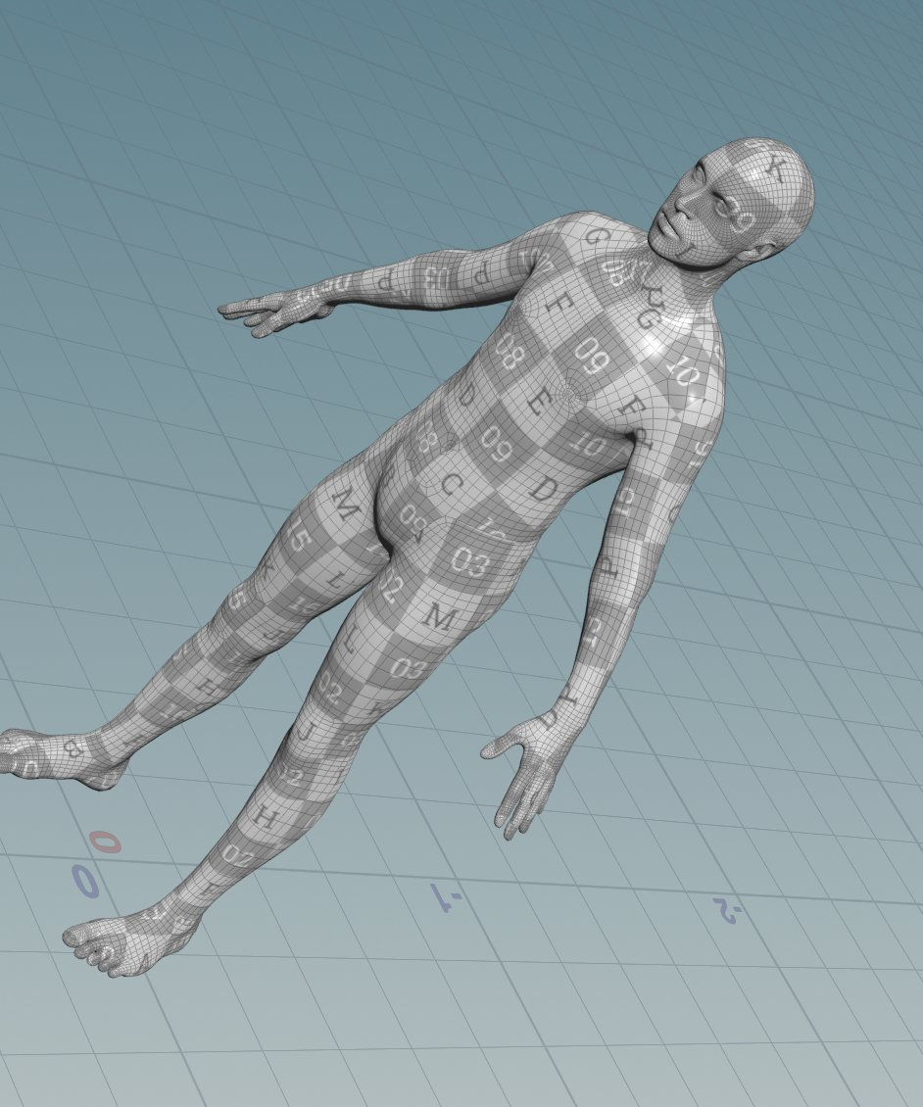
20-shape OOD on tunnel input: model produces a humanoid figure (the closest training shape to the tunnel's silhouette in DINOv2 feature space). The output bears no resemblance to a tunnel.
This is exactly the predicted failure mode for diffusion at small data scale. With 20 training shapes covering only the categories table/blade/pants/wheel/etc., there is no 'tunnel-like' region in the latent space for the model to populate. The DiT correctly learns its 20 (image, latent) pairs and otherwise behaves as a nearest-neighbor retriever in DINOv2 feature space.

7.4 Scaling to 976 Shapes: Genuine Generalization
The same pipeline at 976 training shapes produces qualitatively different OOD behavior. Final training EMA: 5.1×10⁻³ (much higher than the 20-shape memorization, which is exactly what we want — the model can no longer memorize).

Recall: Still Strong
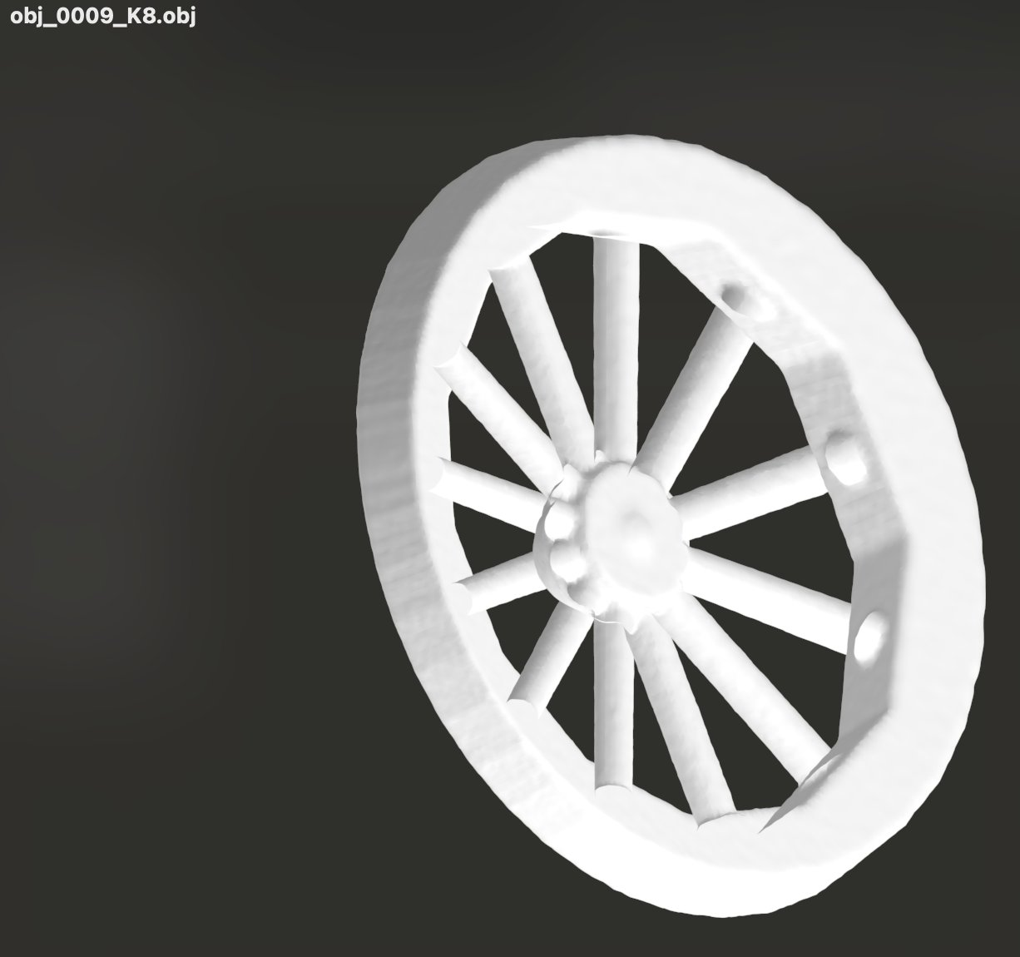
Recall at 976 shapes: obj_0009 (wagon wheel) reconstructs cleanly through the full image-to-3D pipeline, comparable to the direct latent decode.

OOD Generalization: Real, but Rough
We test three out-of-distribution inputs: a posed humanoid figure mesh (not in training), a thin tunnel mesh, and a clean head-and-shoulders bust.
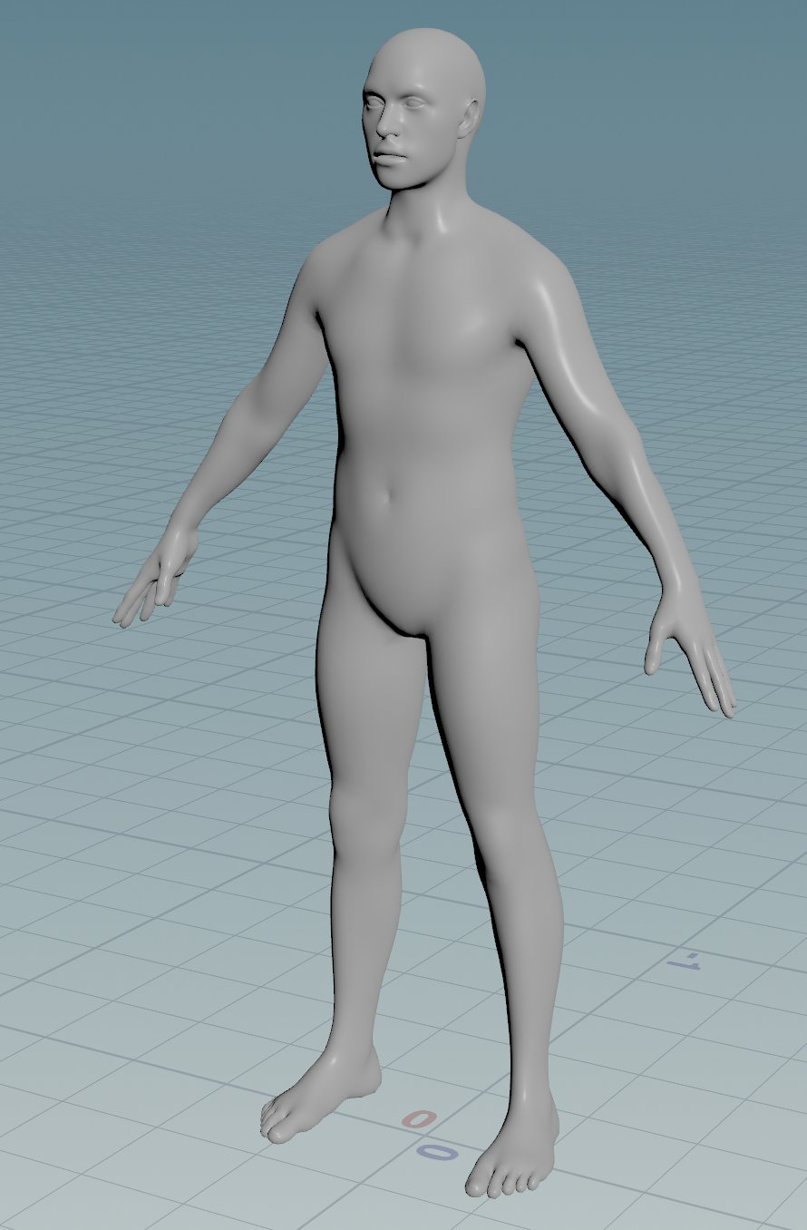  Input: humanoid figure | 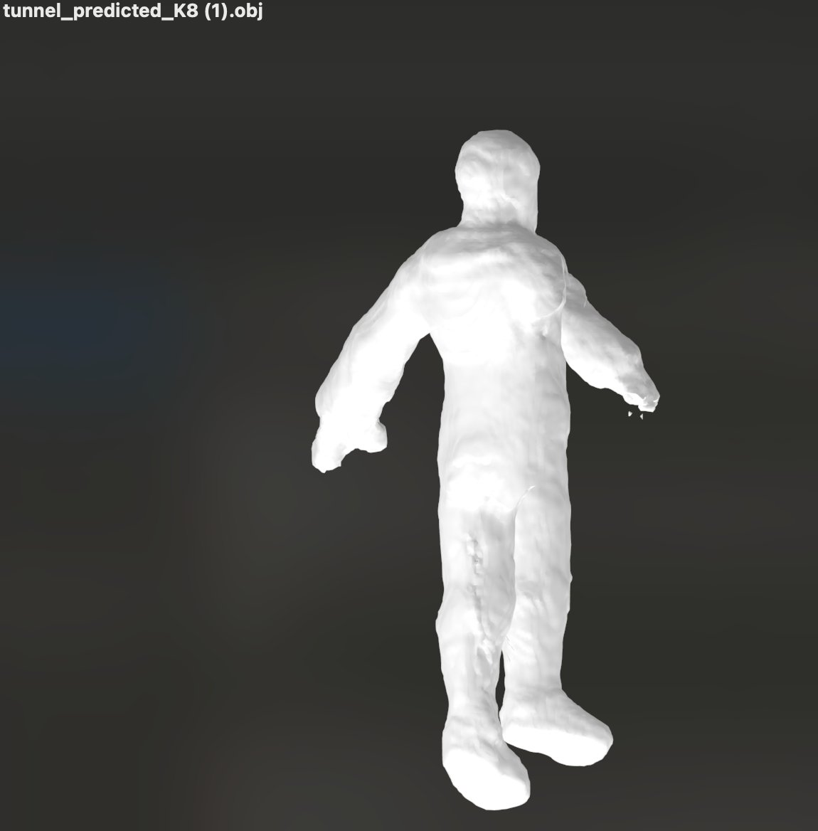  Phase 12 output (K=8)
Figure 4a: OOD on human body. The model has never seen this specific human, but it produces an unmistakably humanoid output: head, shoulders, outstretched arms, torso, legs, feet. Surface quality is rough — no fingers, mushy facial detail — but the topology is right.
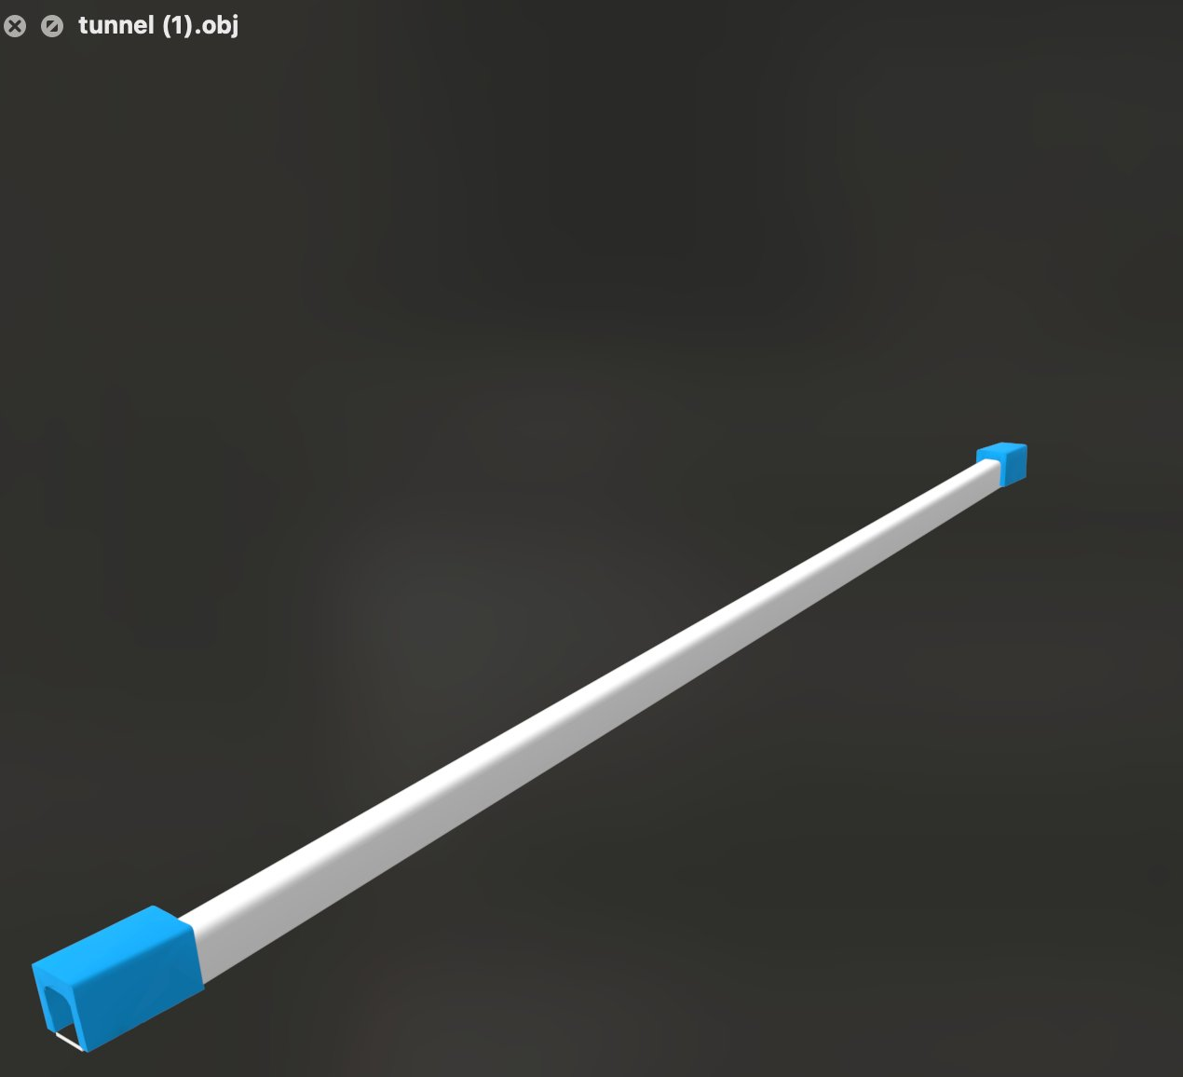  Input: tunnel (thin rod) | 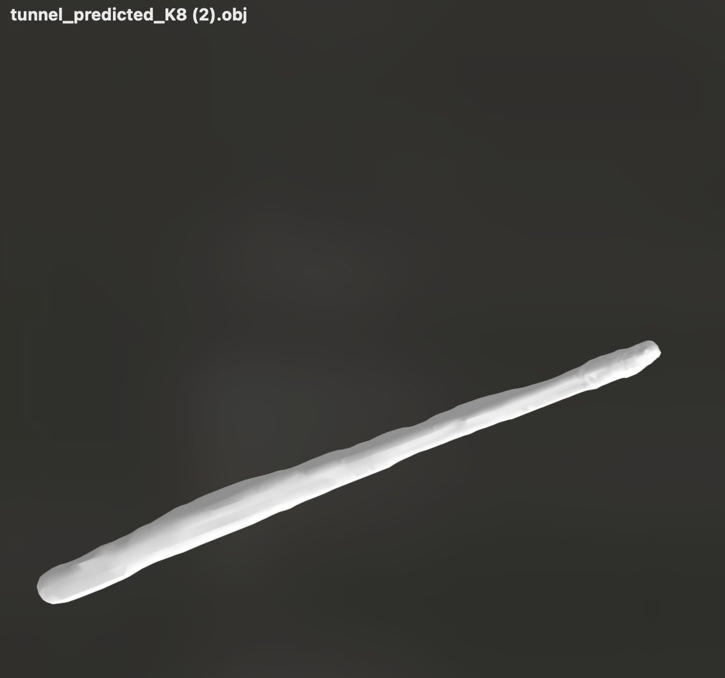  Phase 12 output (K=8)
Figure 4b: OOD on tunnel. At 976 shapes the model produces an elongated rod-like output, recognizing the long-thin geometry. Compare to the 20-shape result (Figure prior), which collapsed to a humanoid figure entirely.
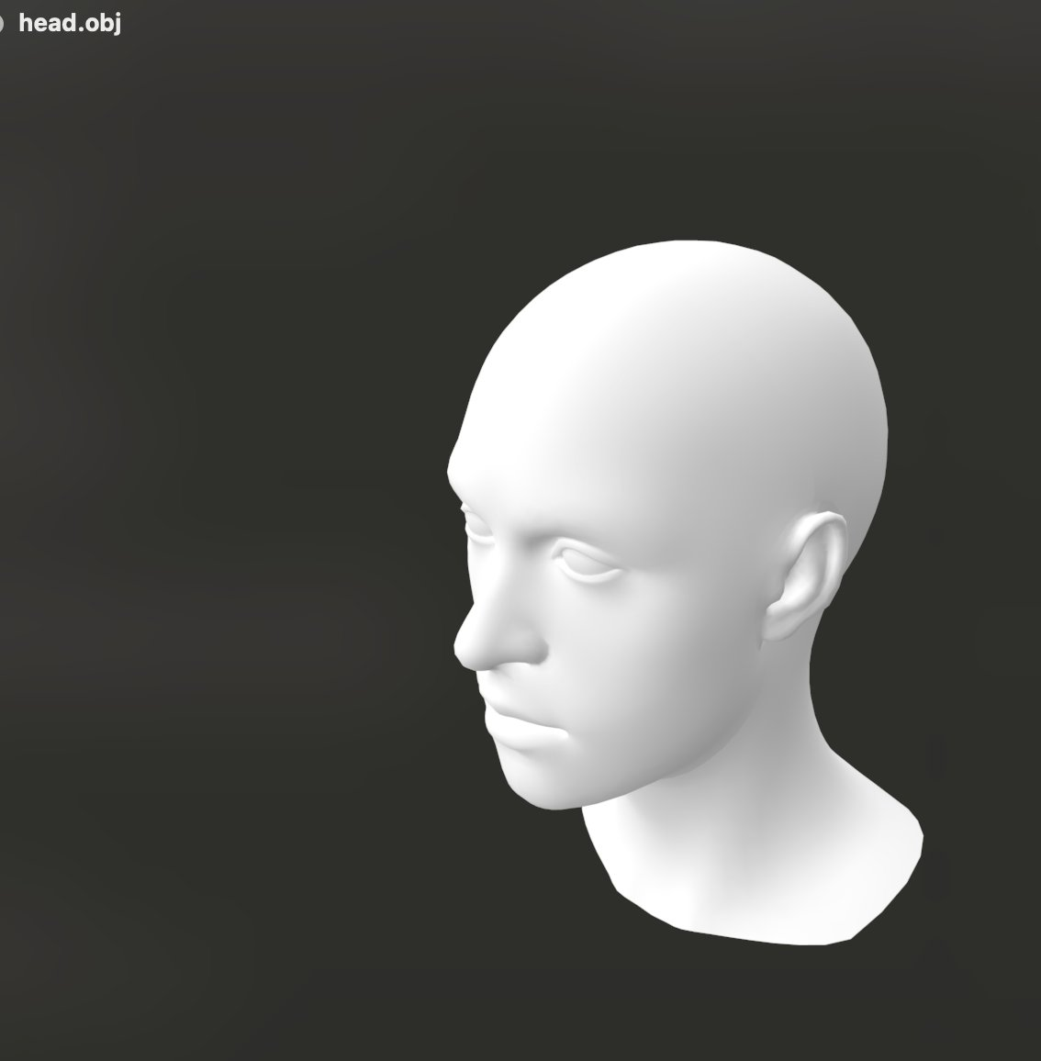  Input: head bust | 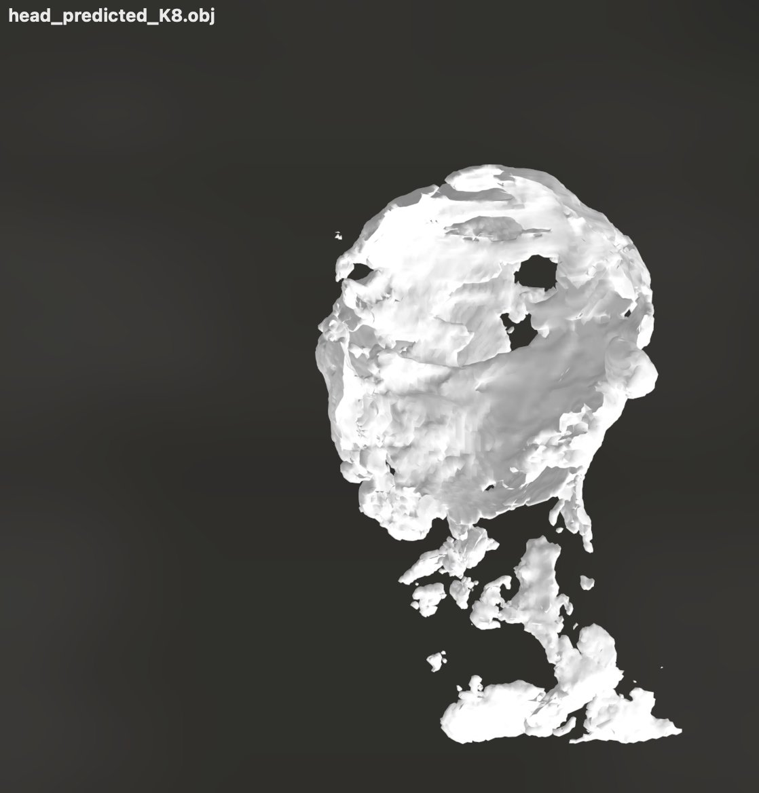  Phase 12 output (K=8)
Figure 4c: OOD on head/face. The output preserves the head-on-shoulders topology with eye-socket-like depressions, but loses fine facial features. Below the head, the neck/shoulder region degrades into noise — the model has learned 'head-like' but not 'cleanly attached to torso'.
The qualitative shift from 20-shape pure-retrieval to 976-shape category-appropriate generation is the most important result of this work. The latent space at 976 shapes has acquired enough semantic structure that DINOv2 features can navigate it: a humanoid input lands in a humanoid region, a long thin input lands in a long-thin region, a head input lands in a head region. The decoder produces the appropriate gross topology even for never-seen inputs.
This is not yet 'real' image-to-3D in the sense of large-scale systems like Shap-E or Get3D. The reconstructions are rough, fine details are lost, and category-appropriate does not mean shape-faithful. But it is qualitatively beyond pure retrieval, and at 976 training shapes — about 10⁻³ of the data scale of those large-scale systems — that is what we should hope for.

8. Discussion

8.1 The Warm-Start Trap
The most counterintuitive finding of this work is that the warm-start prior — established as essential for downstream weight-space tasks in our prior work on per-layer hypernetworks — is precisely what dooms image-conditioned weight-space diffusion at our data scale.
Warm-starting all per-shape MLPs from a single anchor produces a weight distribution that lives in a thin shell of weight space (mean pairwise cos = 0.96). For unconditional weight-space interpolation, this is desirable: every weight vector you might land on is in the same permutation neighborhood, so interpolation is structured. For image-conditioned diffusion, the same property is fatal: the per-shape signal is buried under the shared anchor structure, the diffusion model sees mostly noise relative to its target, and it collapses to predicting the mean.
The DeepSDF approach sidesteps this trap by never having per-shape weight vectors in the first place. Per-shape variation is constrained to a 64-dim latent space by construction, and the shared decoder cannot rely on a fixed anchor — it must use the latent code to differentiate shapes.

8.2 Numerical Metrics vs Geometric Reality
The Phase 10 weight autoencoder is a clean example of metrics that mislead. cos(rec, true) = 0.997 sounds excellent and is excellent for almost any application except this one. But the residual 0.3% error lands on different dimensions for different shapes, and ReLU+PE decoders are non-uniformly sensitive to perturbations: a small error on a critical bias term destroys topology, while a large error on an inactive ReLU does nothing.
Visual inspection of marching-cubes outputs is, in our experience, the only reliable way to evaluate the success of weight-space methods. We have made it a hard rule for ourselves never to declare success based on numerical metrics alone, and to specifically check shapes with thin or topologically complex geometry (wagon wheels, multi-part figures) as the most informative stress tests.

8.3 The Data Scale Question
All our negative results from Sections 4-5 should be read with the caveat 'at 976 shapes'. We have not shown that weight-space diffusion is impossible in principle — only that the warm-start prior plus 976 training shapes places it below the threshold of feasibility. With 10⁵ shapes, there is enough per-shape variation in the warm-started distribution that the diffusion model could plausibly extract it. With 10⁶ shapes, almost certainly. The scale at which weight-space diffusion 'turns on' is an empirical question we have not answered.
Conversely, the Phase 11+12 success at 976 shapes does not establish that DeepSDF is uniformly superior. At very large scale, the weight-space approach may have advantages we cannot see at our scale — for example, it does not require choosing a latent dimensionality up front, and it can in principle adapt MLP capacity to per-shape complexity.
What we have established is a lower bound: at the small-data scale typical of academic and applied research, the DeepSDF approach is robustly superior to weight-space diffusion variants we have tested.

8.4 Limitations of the Final System
The Phase 12 / 976-shape image-to-3D pipeline has clear limitations:
- Surface quality of OOD outputs is rough: no fine detail, mushy faces, no fingers, broken neck attachments. This is the expected manifestation of data scale: the latent space is sparsely populated, and DiT predictions for novel inputs land in under-trained regions of the latent space that decode noisily.
- Fine geometric features (the holes in a wagon wheel hub, the curl of a snowman's hat brim) are present in training-shape recall but not consistently in OOD outputs. Single-view OOD reconstructions are particularly noisy.
- The system does not handle truly novel categories well. A tunnel produces a long-thin object but not a tunnel with a hollow interior, because nothing in the 976 training shapes has a tunnel-like topology. The model is bounded by the categories present in its training data.
- We have not measured generalization quantitatively across many test shapes — only spot-checked obvious examples (human, tunnel, head). A more rigorous evaluation would require a held-out test set with ground-truth meshes and a 3D shape similarity metric (Chamfer distance, IoU, or learned metrics).

8.5 Future Directions
- Larger scale: 5K, 50K, 500K shapes from full Objaverse. The expected curve based on our 20→976 results is that surface quality and OOD fidelity improve smoothly with shape count.
- More expressive latent spaces: triplane or hybrid latent representations, which combine a small global latent with localized features, could improve fine detail while preserving the structured manifold property.
- Latent-space regularization: training the DeepSDF stage with explicit smoothness regularizers (KL divergence to a Gaussian prior, latent interpolation losses) could make the latent manifold smoother and improve OOD decoding.
- Richer image conditioning: combining DINOv2 with depth estimators or surface-normal estimators could give the DiT more 3D-structural information per view, reducing dependence on training-set coverage.
- Quantitative OOD evaluation: building a held-out test set with ground-truth meshes and computing Chamfer / IoU scores to measure generalization rigorously.

9. Conclusion
We have presented a long, somewhat painful empirical investigation of image-to-3D generation at small data scale. Across twelve experimental phases, we attempted three architectural families: per-shape weight-space diffusion, weight-space autoencoder + diffusion, and DeepSDF + latent diffusion. The first two failed in informative ways. The third succeeded.
The weight-space failures localize to a single underlying cause: the warm-start prior necessary for downstream weight-space tasks creates a training distribution too concentrated for diffusion models to extract per-shape signal. Diagnostic ablations rule out per-dimension standardization, classifier-free guidance dropout, and prediction-target choice as causes, leaving the warm-start dominance as the explanation.
The weight-space autoencoder bypasses the dimensionality problem but creates a new one: ReLU+PE decoders are non-uniformly sensitive to weight perturbations, and an autoencoder optimizing aggregate weight MSE has no signal about which perturbations are catastrophic in SDF space. Numerical reconstruction quality (cos = 0.997) is uncorrelated with mesh quality.
The DeepSDF approach succeeds because it constrains per-shape variation to a 64-dim latent space by construction, rather than attempting to extract it from a high-dim weight space. With 976 training shapes, the latent space acquires sufficient semantic structure that an image-conditioned DiT can navigate it for OOD inputs: humanoid in produces humanoid out, head in produces head out, long thin in produces long thin out.
The journey is the message. Eight architectural iterations, several thousand GPU-hours, and many late-night debug sessions led to a single sentence of insight: at small data scale, structural inductive biases that constrain the prediction space (DeepSDF's shared-decoder + small-latent architecture) beat learned compression of an unconstrained representation (per-shape MLP weights) every time. We expect this insight to generalize beyond 3D shapes to other domains where the prediction target is high-dimensional, structured, and learned through warm-starting.

Acknowledgements
The watertight conversion pipeline (Houdini VDB) and SDF sampling toolchain were developed in earlier phases of this project. The DINOv2-base/14 weights are from the Meta AI public release. All experiments ran on a single Vast.ai instance with an NVIDIA RTX 5060 Ti (16 GB).

References
- Park, J. J., Florence, P., Straub, J., Newcombe, R., Lovegrove, S. (2019). DeepSDF: Learning Continuous Signed Distance Functions for Shape Representation. CVPR.
- Sitzmann, V., Martel, J. N. P., Bergman, A. W., Lindell, D. B., Wetzstein, G. (2020). Implicit Neural Representations with Periodic Activation Functions. NeurIPS.
- Erkoç, Z., Ma, F., Shan, Q., Nießner, M., Dai, A. (2023). HyperDiffusion: Generating Implicit Neural Fields with Weight-Space Diffusion. ICCV.
- Deitke, M., Schwenk, D., Salvador, J., et al. (2023). Objaverse: A Universe of Annotated 3D Objects. CVPR.
- Gupta, A., Dollár, P., Girshick, R. (2019). LVIS: A Dataset for Large Vocabulary Instance Segmentation. CVPR.
- Oquab, M., Darcet, T., Moutakanni, T., et al. (2023). DINOv2: Learning Robust Visual Features without Supervision. arXiv 2304.07193.
- Peebles, W., Xie, S. (2023). Scalable Diffusion Models with Transformers. ICCV.
- Ho, J., Jain, A., Abbeel, P. (2020). Denoising Diffusion Probabilistic Models. NeurIPS.
- Song, J., Meng, C., Ermon, S. (2021). Denoising Diffusion Implicit Models. ICLR.
- Mildenhall, B., Srinivasan, P. P., Tancik, M., Barron, J. T., Ramamoorthi, R., Ng, R. (2020). NeRF: Representing Scenes as Neural Radiance Fields for View Synthesis. ECCV.

